Image | 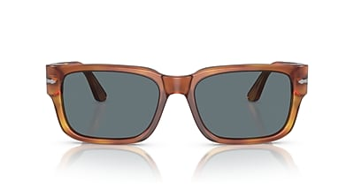
Brand | OLIVER PEOPLES
Model Name | PO3315S
Price | RS 3679
PRODUCT DETAILS

